Microcontroller Lab Assignment
Purpose:
Learning to use microcontrollers serves a variety of purposes for biomedical engineering students. Most importantly, it gives experience with a ‘full stack’ of computing that includes capturing signals, using computing hardware, triggering outputs, and writing appropriate code to do the above. Learning that is useful both professionally and in your education. You will use these skills as part of phase 3 in BMED2250 and reuse them in later courses in our curriculum – including BMED3110 (Quantitative Physiology Lab 1). More importantly, just understanding how computer software and hardware interact to implement engineering thinking is critical in modern engineering work.

Basic instructions and submission:
In this ‘lab’ are four tasks that you will complete individually with an Arduino microcontroller. Any microcontroller can perform the tasks outlined in this lab, but the Arduino Nano will be used as a reference. The first three tasks are practice, they are laid out explicitly in this document and are also demonstrated in a matching video walkthrough. The fourth task is what you will be assessed on. That task has minimal instructions, and requires you to implement a simple mathematical algorithm into software code. You will demonstrate your ability to complete that task, and trouble shoot problems with that task, during class in front of a TA on a day to be specified.

Submission instructions:
- You must demonstrate task 4, in person, during class on November 19th or 20th.
- During class, one TA will be stationed at a table in the hallway outside the PBL rooms
- Critical: When you come to demonstrate Task 4, you must demonstrate it independently and all at once (meaning without outside assistance or other teammates present). There is no partial completion.
- Critical: You may bring a prebuilt circuit and prebuilt code. However, if you do so, the TA can and will ask you to explain your circuit and may ask you to adjust your code to accommodate small changes they make to your circuit.
- Class time on the day the lab is submitted is not supposed to be spent on this assignment. TAs are not allowed to help you while testing your circuit, and we expect your team to be engaged in normal studio work during the remainder of the class period.
- Once you have successfully finished, the TA will immediately mark your points.
- If you do not successfully complete the assignment during class, or you are not prepared to do so when called upon, you may complete it at special TA office hours (TBD) using a resubmission token.

Grading Specifications:
To receive a passing grade on this assignment it must meet each of the following specifications
- Demonstrate a working circuit and software code that completes task 4
- Answer reasonable questions about the function of the hardware and software that you demonstrate
- Trouble shoot and implement a software fix to a change to your circuit made by the TA

Microcontroller information and resources
Microcontrollers are powerful tools used for prototyping systems that combine computing hardware and software. These programmable devices allow engineers to test circuit design and sensor function without having to create custom printed circuit boards (PCBs) or solder components together.
There are many types of microcontrollers, but all microcontrollers integrate a small processor (e.g., ATmega328) into an easy to interact with PCB (e.g., Arduino Uno, Nano, Due, Rasbery Pi Pico, etc.). Critically, a microcontroller (e.g., an Arduino) is a prototyping tool. The goal is to make it easy to build circuits that interact with a microprocessor. Final designs will typically integrate the same or similar microprocessor on a custom (i.e., less expensive and smaller) circuit boards. These boards allow for the direct temporary connection of a circuit to the processor via a series of “pins.” Engineers can test how circuits communicate with the processor or even collect data from sensors before finalizing a design.
While any microcontroller can perform the tasks outlined in this lab, we will use the Arduino Nano (Figure 1) as a reference and suggest that you use this device for simplicity. Arduino microcontrollers run a version of the programming language C++. You can write software in the Arduino ‘IDE’ or in Matlab.
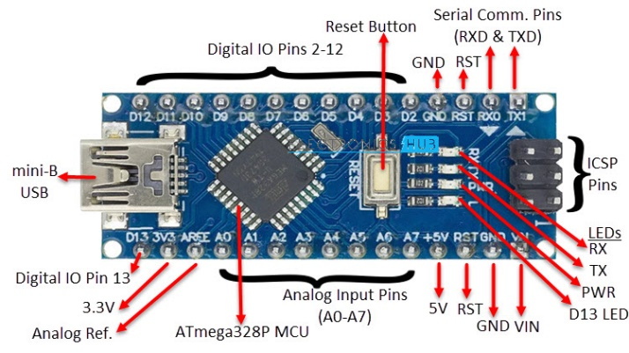
Figure 1. Basic Layout of Arduino Nano microcontroller. Software code runs on the ATmega processor located near the middle of the board (the black square). The pins along the edges of the board allow you to connect the Nano to circuits of your own design with digital and analog inputs and outputs.
Helpful resources:
Working with microcontrollers for the first time can be frustrating. Your TAs are a good resource to turn to. The following websites are also great places to go to get your troubleshooting questions answered:

Web Guides:
- Arduino Support
- Troubleshooting Arduino Sketches
- Troubleshooting Guide for Arduino
- Paul McWhorter YouTube Tutorials (most relevant: videos 3, 12, and 14)
- Pulse Width Modulation
- Arduino Nano Pin Out

Major note:
You are welcome to use any microcontroller, including any Arduino or even a non-Arduino. However, we are only prepared to support the Arduino nano, so there are no guarantees we can assist if you need help. Our recommendation for the Nano is based on what we believe best fits the needs of the class as well as our limited ability to ask TAs and faculty to support the potentially vast number of such devices.
Necessary software:
The Arduino Integrated Development Environment (IDE) software allows you to write programs specifically for Arduino development boards, upload them to your board. In the Arduino Software page you will find two options you can choose from to access this software:
- If possible, you should use the latest version of the desktop IDE.

- If you have a reliable Internet connection, you can use the online IDE (Arduino Web Editor). It will allow you to save your sketches in the cloud, having them available from any device and backed up. You will always have the most up-to-date version of the IDE without the need to install updates or community generated libraries.
Installing the desktop IDE on a Mac historically has proven to be a bit tricky for some students in this course. In addition, with the desktop IDE, you may find yourself downloading Arduino libraries from sources that are potential security risks (i.e. computer viruses). So, the instructions for this lab are written assuming you are using the online IDE.

The Matlab environment also has the ability to send code to Arduino microcontrollers. You have access to the Arduno support package as part of your GT software license. If you are comfortable writing code for Matlab, you may find this easier. Link: https://www.mathworks.com/hardware-support/arduino.html

Necessary Hardware:
A variety of electrical components will be used in building circuits for this lab. Most microcontroller kits include all these parts but make sure to confirm. Each team will need access to their own set of components:
- Microcontroller
(to reiterate - any microcontroller can perform the tasks outlined in this lab, but we will use the Arduino Nano will be used as a reference for all of the instructions)
- Breadboard
(any size breadboard will work for this lab)
- 2x Light Emitting Diodes (LED)
(any breadboard-friendly LED, meaning one with ‘leads’ or ‘legs’ will work for this lab)
- 2x 1 kΩ Resistors
- Jumper Wires
- Potentiometer
(any breadboard-friendly potentiometer will work for this lab)

Tasks

Task 1

Description:
The Arduino nano contains four onboard LEDs (see Figure 1). One LED indicates that the microcontroller is receiving power and should be on whenever the microcontroller is plugged in. The middle two LEDs light up to indicate that the Arduino is receiving or transmitting data to the attached computer. The last LED is controllable in the Arduino software code via a digital pin (D13). That LED is useful to confirm that your computer is able to successfully load software onto the Arduino before interacting with external circuitry. It is the simplest functional test – so it is important to do first.

Goal:
Blink the internal LED at a specified rate to confirm loading software on the microcontroller.

Success criteria:
When the sketch is uploaded, the internal LED blinks at a stable and continuous rate.

Steps:
- Access an IDE compatible with your microcontroller. For Arduino boards:
  - Open the online IDE on a laptop and create an account.
  - If using the desktop IDE – you can copy code you need from the cloud editor guide in step 4
- Insert the microcontroller into the breadboard (see figure 2)
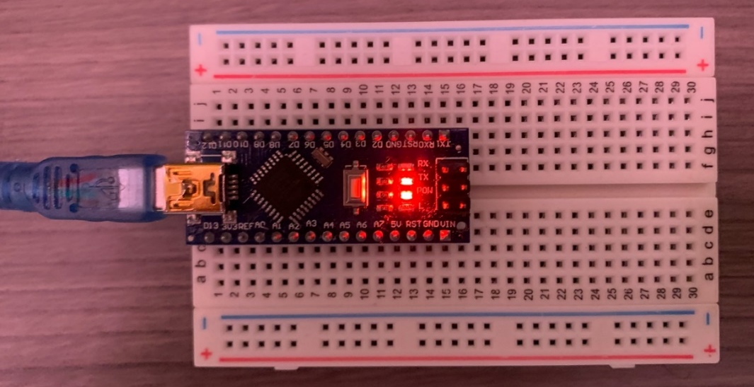
Figure 2. Arduino properly mounted with two rows of pins attached to opposite sides of the breadboard
- Use an appropriate USB cable to connect a laptop USB port to the Arduino’s microUSB port.
- Follow the cloud editor guide instructions to confirm microcontroller function.
- Follow steps outlined in the “Setup” section of the cloud editor guide.
  - In step 3, you will open and upload a ‘sketch’ (software code) called Blink
  - When you upload the Blink sketch, your onboard LED should start to blink

Tips and considerations:
- Does the code reference the right digital pin?
- Does your IDE recognize (‘see’) your microcontroller as attached to your laptop?
- If you change the delay times and re-upload the sketch, does the blink rate change?

Task 2

Description:
This section will teach you one of the main uses of a microcontroller: programming outputs to control an external circuit. You can use your microcontroller to control a variety of circuits. We will demonstrate this ability by creating a circuit and code that blinks one LED while keeping another LED powered on

Goal:
Confirm that the microcontroller successfully can output a digital signal to control an external circuit

Success criteria:
- One external LED stays on as long code is running on the microcontroller
- One external LED blinks at the specified rate

Steps:
- Disconnect the Arduino from your computer (IMPORTANT).
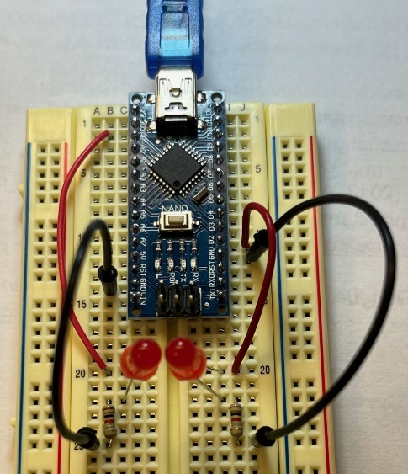
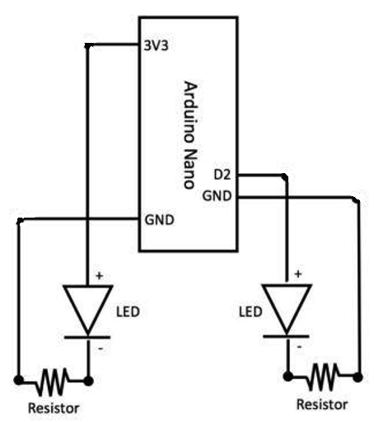
- Construct the circuit diagramed in Figure 3. The circuit requires 2 LEDs, 2 1kΩ (i.e. 1000 ohm) resistors, and 4 jumper wires. Please use the 3.3V pin, Digital Pin 2, and Ground pins.
The triangles with bars at the ends represent LEDs. The black circles in the diagram indicate the wires/components are electrically connected via the breadboard. Crossing wires without a circle do not indicate a connection.
Figure 3. The circuit (a) as implemented on an Arduino nano and (b) schematically
- For your circuit for the always on LED (left side of schematic)
  - Connect one end of a jumper wire to the “3V3” (3.3 V) pin on your microcontroller and the other end to an empty component row on the breadboard.
  - Connect one end of a 1 kΩ resistor to the component row connected to the jumper wire and the other end of the resistor to a new, empty component row.
  - Connect the long (anode) leg of the LED to the component row connected only to the resistor and the short (cathode) leg of the LED to a new, empty component row.
  - Connect one end of a jumper wire to the component row connected only to the LED cathode and the other end to a “GND” (ground) pin of the microcontroller.

- For your circuit for the blinking LED (right side of schematic)
  - Follow the same procedure from step 2 using two new jumper wires, one new LED, and one new resistor to create a matching second circuit.
  - Make sure to use new component rows that are not connected to the circuit from step 2 and a digital pin (such as pin “D2” on the Arduino Nano) instead of the 3V3 pin.
- Write and upload code to your microcontroller that makes the LED connected to the digital pin blink on and off continuously while the LED connected to the 3V3 pin remains on.
  - Edit the “Blink.ino” script to use your digital pin (such as “D2” on the Arduino Nano) instead of the built-in LED (“LED_BUILTIN”).
  - Connect the microcontroller to your computer and upload the script.
  - The LED plugged into 3.3V should immediately turn on.
  - The LED plugged into the digital pin may or may not turn on
- Verify that the LED connected to the 3V3 pin remains on while the LED connected to the digital pin blinks continuously.

For reference, here are some of the functions used in this task:
- pinMode(PIN#, PIN_TYPE) – This function is responsible for setting up digital pins as either input or output. Remember, the digital pins on the Arduino can be set as either input or output pins, so you need to tell the program how to treat the pins you will be using in the setup() program.
- digitalWrite(PIN#, VALUE) - This function is responsible for setting the states of your output pins. When the second, input parameter is HIGH the corresponding pin is set to low (3.3V). When set to LOW, the corresponding pin is set to low (0V).
- delay(TIME) – This function will wait to execute the next line of code in the program for as many milliseconds as you tell it to. Think of a delay as the program taking a break before continuing.

Tips and considerations:
- If you change the Pin the LED is connected to, you need to change the Pin specified in code
- Is the LED connected to a 3.3V pin?
- Each Arduino sketch contains two functions specified by ‘void’. The first loop is called setup, and runs once when the board is powered on. The second, called loop, runs continuously, after the setup function is complete, until the board is powered off.
- Resistor values are identified by color codes. Please refer to Figure 4 for help.
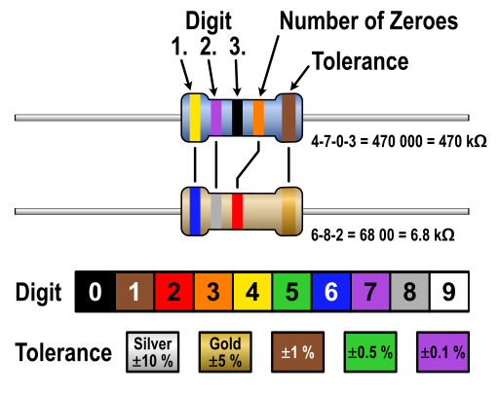
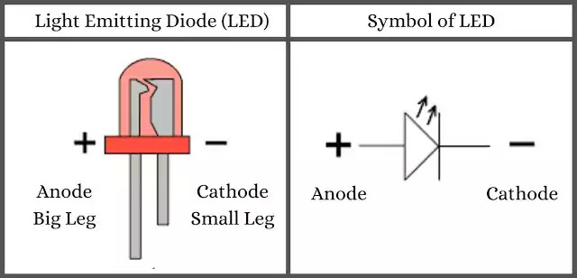
- With LEDs, orientation in your circuit is CRITICAL. Current can only flow through an LED in one direction: from the positive (anode, longer lead) to the negative (cathode, shorter lead).

Figure 5. LED
Figure 4. Resistor color code and LED Anode/Cathode visualization

Task 3

Description:
This task demonstrates the opposite functionality of the Arduino in the previous task. Instead of controlling a digital output you are reading an analog input. You will use a potentiometer (a type of variable resistor that changes its resistance based on the position of its rotatable knob) as a source of information and read that information via your Arduino. This section ALSO shows you how to use microcontrollers to take readings from sensors. You will use the potentiometer to model such inputs.

Goal:
Use the microcontroller to measure and report voltage levels that are varied by changing the resistance applied to a constant voltage by manipulating a potentiometer

Success criteria:
- Text is printed to a laptop showing the voltage level (in 0-1023 units) while the board is powered on
- When the potentiometer is adjusted, the printed numbers change

Steps:
- Disconnect the microcontroller from the computer and remove all wires, resistors, and LEDs.
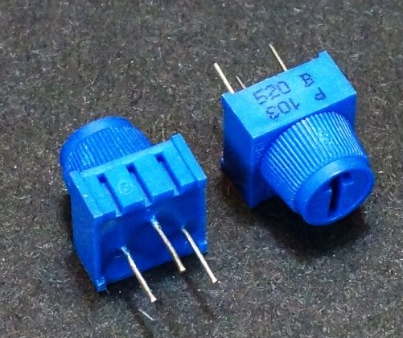
- Identify the potentiometer, it is typically a blue rectangular component with three pins protruding from the bottom surface, similar to that illustrated in Figure 5.
Figure 5. Potentiometer
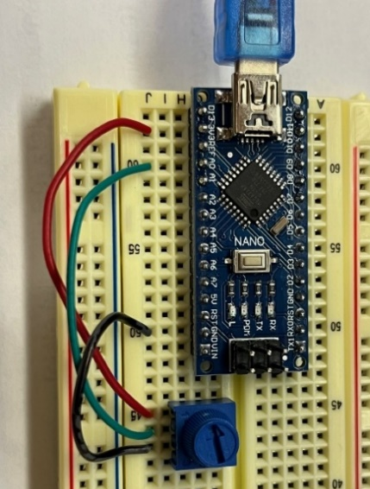
- Insert these three pins onto the breadboard as illustrated below (Figure 6b). Note that the potentiometer has a “1” and a “3” labeled on it. Make sure to connect the leftmost pin, often labeled “1”, to power (i.e. 5V or 3.3V), and connect the rightmost pin, often labeled “3”, to ground. Then, connect the middle pin to an analog input pin on the Arduino Nano.
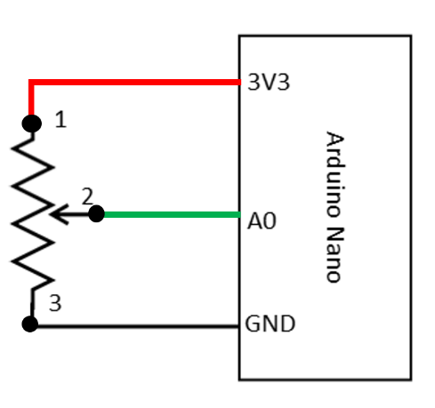
- Check your wiring – each pin on the potentiometer should be connected to something.

Figure 6. (a) Left: Circuit diagram; (b) Right: Photo of circuit
- Reconnect your Arduino to your laptop – nothing should happen
- Open the Arduino IDE and upload the ReadAnalogVoltage sketch to the Arduino. You can find the sketch and code by navigating as follows: Editor > Examples > 01.Basics > ReadAnalogVoltage
- Once the ReadAnalogVoltage sketch has been uploaded, open the Serial Monitor by navigating to the Editor toolbar and click ​Editor > Monitor​. You should immediately see the voltage at A0 (i.e., the voltage of pin 2 of the potentiometer) scrolling down the panel.
- Turn the potentiometer from fully CW to fully CCW and you should see the numbers printed to the Monitor change. Those numbers reflect voltage being read by the analog input pin.

Tips and considerations:
- The most common error is that the potentiometer is wired incorrectly
- The second most common error is that the code is telling the Arduino to read a different analog pin than the potentiometer is actually plugged into
- You may not see 0 (i.e., 0V) or 1023 (i.e., 5V) depending on the range of resistance that your potentiometer provides.
- The variable voltage drop (i.e., variable resistance) across the potentiometer happens between pins 1 and 2 on the potentiometer, meaning the voltage output from pin 2 is variable, which is why we connect the output from pin 2 to the analog input pin on the microcontroller.

Task 4

Description:
Using what you have learned, and the physical components used this far, you will combine digital control and analog control to create a dimmable LED. Once you have finished, demonstrate the functioning dimmable LED to your facilitator.

Goal:
Create a circuit and software code that uses an analog potentiometer to control the brightness of an external LED using your microcontroller.

Success criteria:
Turning the potentiometer changes the apparent brightness of an external LED

Steps:
N/A – you are on your own here.
As a hint: you will need to use ONE new software function – noted below – and combine parts of both circuits that you have already built.

Tips and considerations:
- You can use the same physical components from Tasks 2 and 3 to complete this task.
- LEDs should always be directly connected to a resistor as demonstrated in Task 1
- Your code should probably use the analogWrite(pin, value) function.
- AnalogWrite automatically converts voltages to a type of signal known as pulse width modulation (PWM). PWM is a method of producing an analog voltage by turning a digital signal on and off very precisely to approximate an analog signal
- Only PWM capable pins on an Arduino can be used with analogWrite. PWM pins are marked with a tilde (“~”) next to the pin number on the board.
- Arduinos read analog voltage from 0 volts to 5 volts as an integer scale from 0-1023.
- Arduinos output analog voltages on a scale of 0-255.
- The simplest way to convert from analogRead to analogWrite is to divide analogRead by 4

